**Challenge Problem 03**

The following code generates the famous Collatz sequence. The sequence is started at any integer **n** and continued by dividing **n** by 2 if **n** is even, and multiply **n** by 3 and adding 1 if **n** is odd. A famous unsolved mystery in mathematics is whether or not there exists a value for n where the sequence will not reach 1.

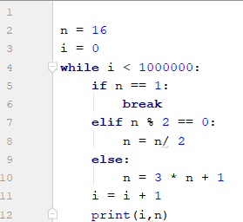

* What is the final value of n?
* What is the final value of i?
* If n = 37, what is the value of n when i=3?
* What value of n such that, 10 < n < 1000, produces the longest Collatz sequence?

Example:

n = 4 -> 4, 2, 1

n = 5 -> 16, 8, 4, 2, 1

Therefore n=5 generates a longer collatz sequence than n=4.